# 4×4 Keypad

A 4×4 keypad is a matrix keypad with 16 buttons arranged in 4 rows and 4 columns, used as an input device for microcontroller-based systems.

**Working Principle:**  
Each key connects a unique row and column. When a key is pressed, the row and column line are connected, and the microcontroller scans the matrix to identify which key was pressed. 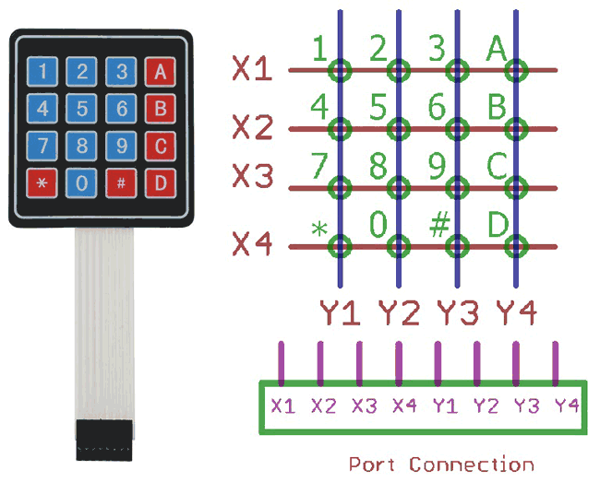

**Types**:  
- 3×4 Keypad (12 keys)  
- 4×4 Keypad (16 keys)  
- Membrane and mechanical types

**Applications**:  
- Password input systems  
- Security locks  
- Menu navigation in embedded devices  
- Calculator projects

**Advantages**:  
- Compact and efficient  
- Simple wiring using matrix scanning  
- Easy to integrate with Arduino

**Disadvantages**:  
- Needs debouncing in code  
- Not very durable (membrane types)